# **Tenses**

There are three main tense.

### **1) Present**

**Simple**

* **Urdu**: میں پڑھتا ہوں، لکھتا ہوں، وہ گاتا ہے، وہ کھیلتا ہے، ہم دوڑتے ہیں
* **English**: I read, I write, he sings, he plays, we run

**Continuous**

* **Urdu**: میں لکھ رہا ہوں، میں پڑھ رہا ہوں، وہ سو رہی ہے، بچے کہانی سن رہے ہیں
* **English**: I am writing, I am reading, she is sleeping, children are listening to a story

**Perfect**

* **Urdu**: میں نے لکھ دیا ہے، میں نے کھا لیا ہے، ہم نے کتاب پڑھ لی ہے، اس نے کام مکمل کر لیا ہے
* **English**: I have written, I have eaten, we have read the book, he has completed the work

**Perfect Continuous**

* **Urdu**: میں دو گھنٹوں سے پڑھ رہا ہوں، وہ صبح سے کام کر رہی ہے، ہم گھنٹوں سے انتظار کر رہے ہیں
* **English**: I have been reading for two hours, she has been working since morning, we have been waiting for hours

### **2) Past**

**Simple**

* **Urdu**: میں نے لکھا، پڑھا، کھایا، ہم نے فلم دیکھی، اس نے کام کیا
* **English**: I wrote, I read, I ate, we watched a movie, he worked

**Continuous**

* **Urdu**: میں لکھ رہا تھا، پڑھ رہا تھا، کھا رہا تھا، بچے شور مچا رہے تھے، وہ کتاب لکھ رہی تھی
* **English**: I was writing, I was reading, I was eating, children were making noise, she was writing a book

**Perfect**

* **Urdu**: میں نے لکھ دیا تھا، میں نے پڑھ لیا تھا، اس نے کھانا کھا لیا تھا، ہم نے کام ختم کر لیا تھا
* **English**: I had written, I had read, he had eaten food, we had finished the work

**Perfect Continuous**

* **Urdu**: میں دو گھنٹوں سے پڑھ رہا تھا، وہ گھنٹوں سے اپنی کتاب لکھ رہی تھی، بچے شام سے پڑھائی کر رہے تھے
* **English**: I had been reading for two hours, she had been writing her book for hours, children had been studying since evening

### **3) Future**

**Simple**

* **Urdu**: میں پڑھوں گا، کھاؤں گا، ہم سکول جائیں گے، وہ اپنا کام مکمل کرے گا
* **English**: I will read, I will eat, we will go to school, he will complete his work

**Continuous**

* **Urdu**: میں پڑھ رہا ہوں گا، لکھ رہا ہوں گا، وہ کہانی سن رہا ہوگا، بچے باغ میں دوڑ رہے ہوں گے
* **English**: I will be reading, I will be writing, he will be listening to a story, children will be running in the garden

**Perfect**

* **Urdu**: میں نے لکھ دیا ہوگا، میں نے پڑھ لیا ہوگا، ہم نے کھانا کھا لیا ہوگا، بچوں نے ہوم ورک ختم کر لیا ہوگا
* **English**: I will have written, I will have read, we will have eaten, children will have completed their homework

**Perfect Continuous**

* **Urdu**: میں دو گھنٹوں سے پڑھ رہا ہوں گا، وہ کئی دنوں سے لکھ رہا ہوگا، بچے دوپہر سے کھیل رہے ہوں گے
* **English**: I will have been reading for two hours, he will have been writing for many days, children will have been playing since afternoon

# **Present Tense**

# **Present Indefinite / Simple Tense:**

The **Present Simple Tense** is used to describe actions, events, or situations that are:

1. **Habitual or Regular**: Things that happen repeatedly or regularly.
2. **General Truths or Facts**: Statements that are always true.
3. **Scheduled or Timetabled Events**: Future events with a fixed schedule.
4. **States**: Permanent or unchanging situations.

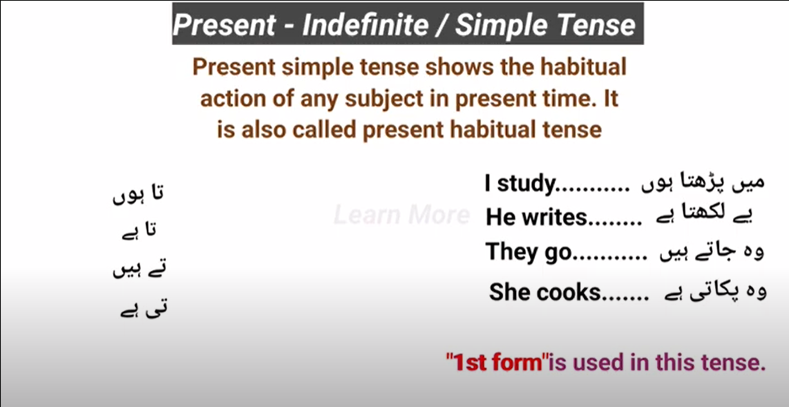

## **Helping Verb:**

1. Do
2. Does

**Note**: Both **do and does** only used in **negative, interrogative, (interrogative: negative) or in emphatic sentences.**

|  |  |
| --- | --- |
| **Do** | **Does** |
| * I * We * You * They * Plural Subject: (Bilal and Haseeb) | * He * She * It * Singular Subject: (Nadir) |

## **Kind of Sentences:**

1. **Positive/Assertive/Affirmative/Declarative Sentences:**

**Formation:**

(**Third-person singular:** He, she, it, nadir)

Subject + (V1) M.V (main verb (+ s/es for third-person singular)) + Object + .

**Examples:**

* I + go + to + school + .
* They + play + cricket + .
* She + Cooks + Biryani

**Rules for adding e/es in singular subject:**

If the subject is **singular** like **he, she or it** and its verb is end with ‘y’ and before ‘y’ we have **consonant** then we remove ‘y’ and add **ies** and if we have vowels before ‘y’ then we just add ‘s’.

|  |  |  |  |
| --- | --- | --- | --- |
| **Consonant** |  | **Vowels** |  |
| Cry | Nadir cries | Play | Nadir Plays |
| Shy | She shies | Say | He says |
| Try | He tries | Stay | She stays |
|  |  |  |  |

If the subject is **singular** like **he, she or it** and its verb is end with words like **“ss, sh, ch, x, o”** then we add **es**

|  |  |  |
| --- | --- | --- |
| Kiss | Kisses | She kisses her child. |
| Smash | Smashes | He smashes her TV. |
| Snatch | Snatches | He snatches toys from children. |
| Box | Boxes | He boxes his opponent forcely. |
| Go | Goes | He goes to office by foot. |

If the subject is **singular** like **he, she or it** and its verb is **not** end with **‘Y’** like **“speak, run”** then we add **s**

|  |  |  |
| --- | --- | --- |
| Speak | Speaks | She speaks. |
| Run | Runs | He runs. |

## **Practice:**

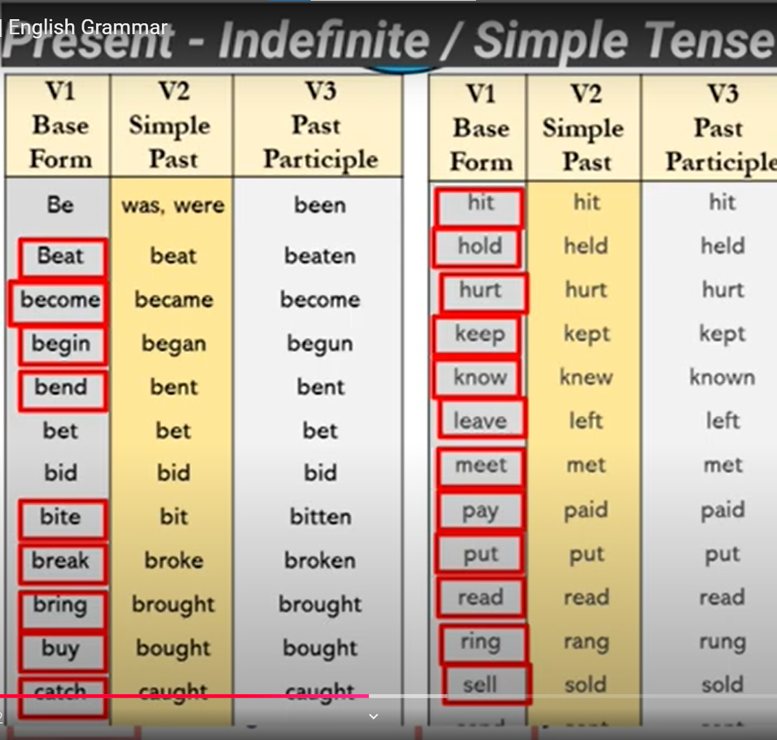

1. **Negative Sentences**:

**Formation:**

Subject + H.V + not + (Verb 1st Form) + Object + .

**Examples**:

* I + do + not + go + to + school + .
* They do + not + play + cricket + .
* She + does + not + Cook + Biryani +.
* He + does + not + play + cricket +.

1. **Interrogative Sentences**:

**Formation:**

H.V (Do/Does) + Subject + (Verb 1st Form) + Object + ?

**Example**:

* Do + I + go + to + school +?
* Do + they + study + English +?
* Does + he + watch + cricket +?

1. **Interrogative: & Negative Sentences**:

**Formation:**

H.V (Do/Does) + Subject + not + (Verb 1st Form) + Object + ?

**Example**:

* Do + I + not + go + to + school +?
* Do + they + not + study + English +?
* Does + he + not + watch + cricket +?
* Do + you + not + each + rice and potatoes +?

1. **Emphatic Sentence:**

**Formation:**

Subject + H.V (Do/Does) + (Verb 1st Form) + Object + ?

**Example**:

* I like to eat mangoes.
* I do like to eat mangoes.
* Doctor serves the nations.
* Doctor does serve the nations.

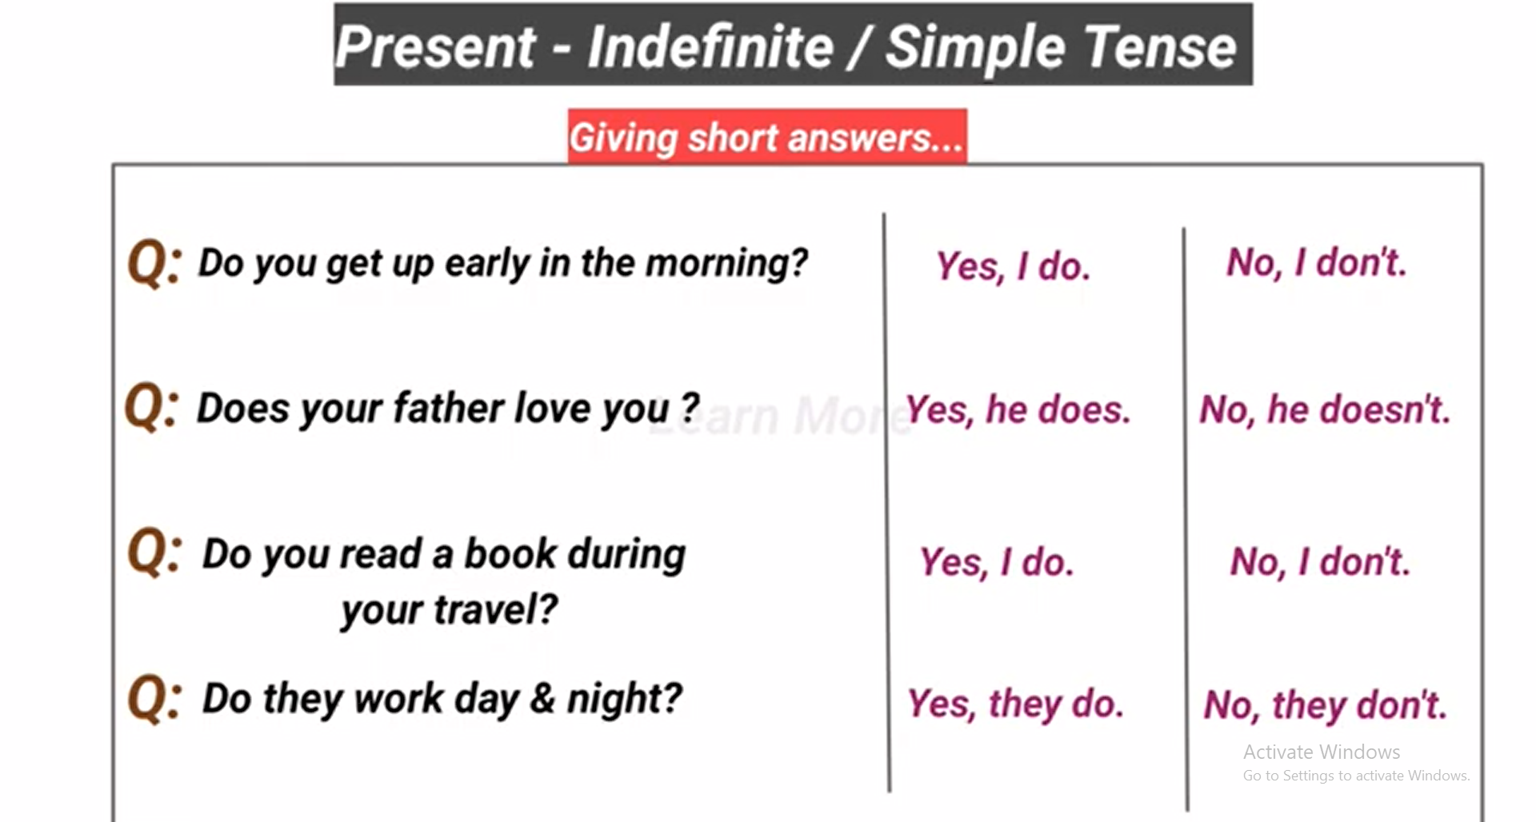

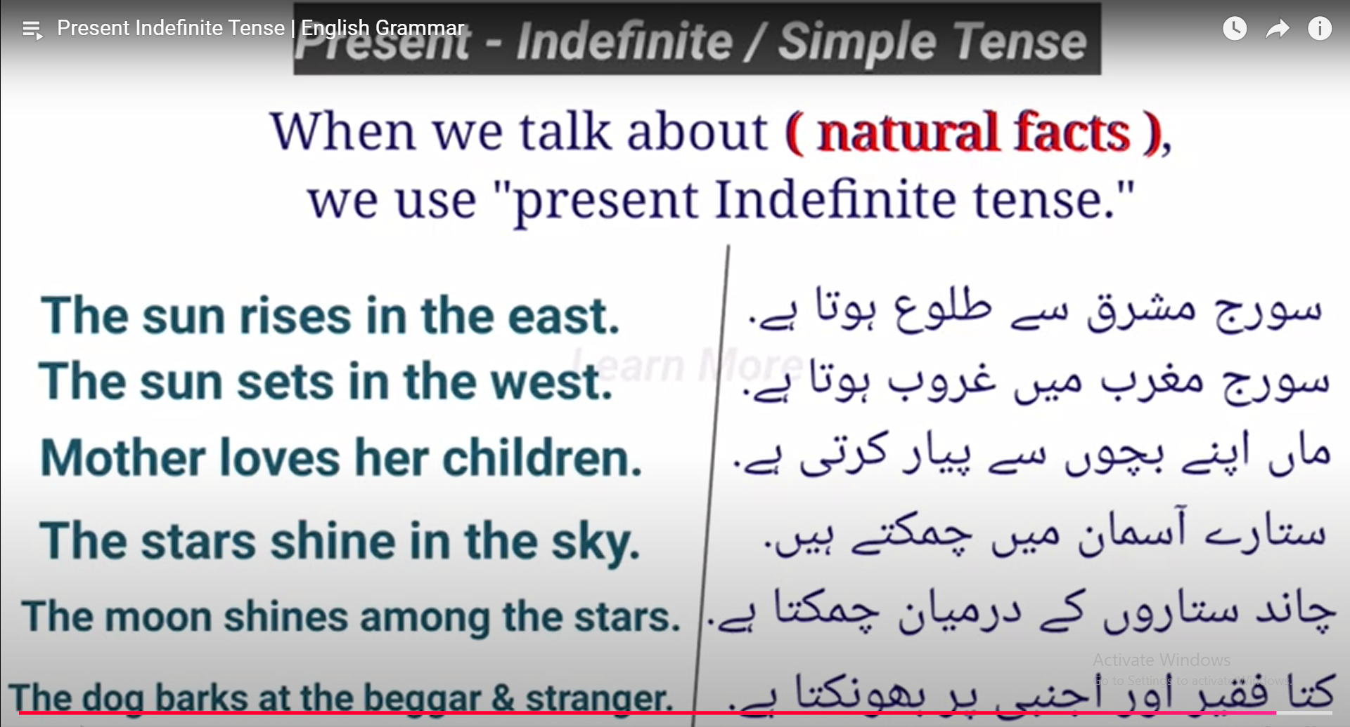

# **Present Continuous Tense:**

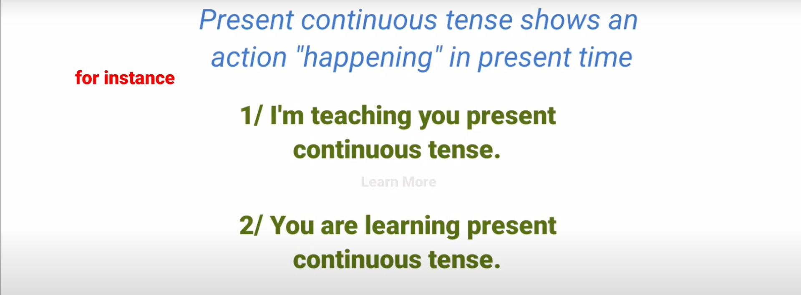

## **Helping Verb:**

|  |  |
| --- | --- |
| Is | He, she, it & nadir (Singular Subject) |
| Am | I |
| Are | We, They, you and (Nadir and Haseeb) |

**Note:** 1st Form of verb + ing is used in this tense. e.g. Playing , Calling , Working etc.

**Important Rules:**

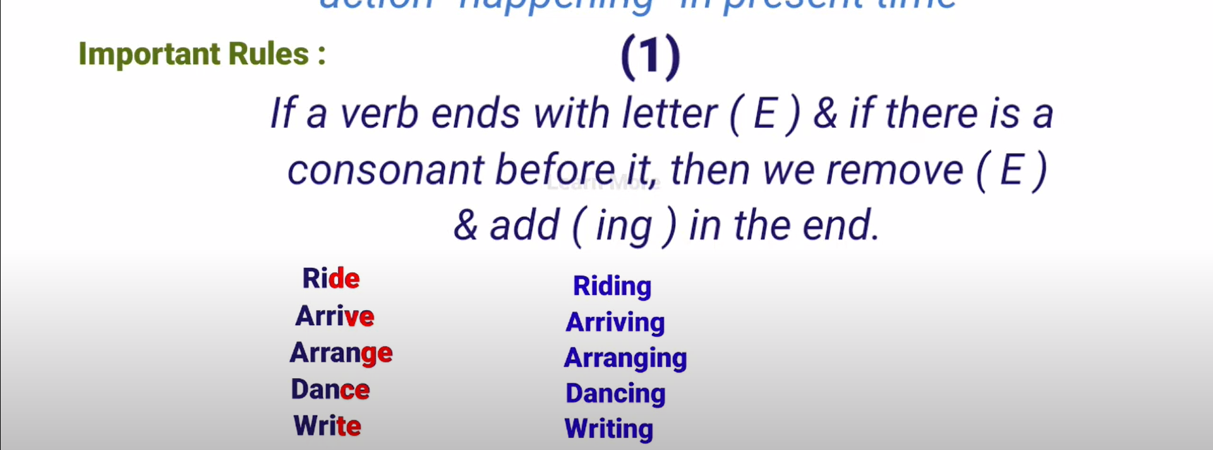

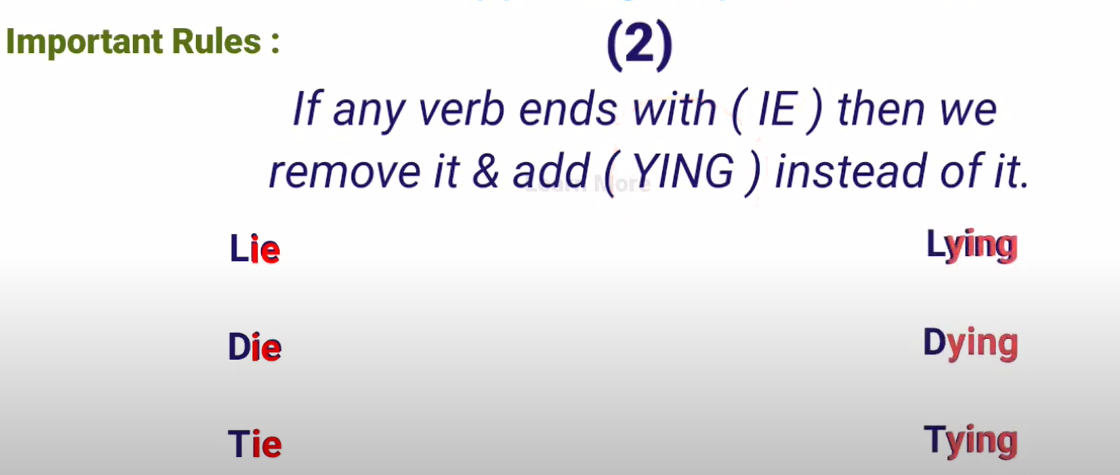

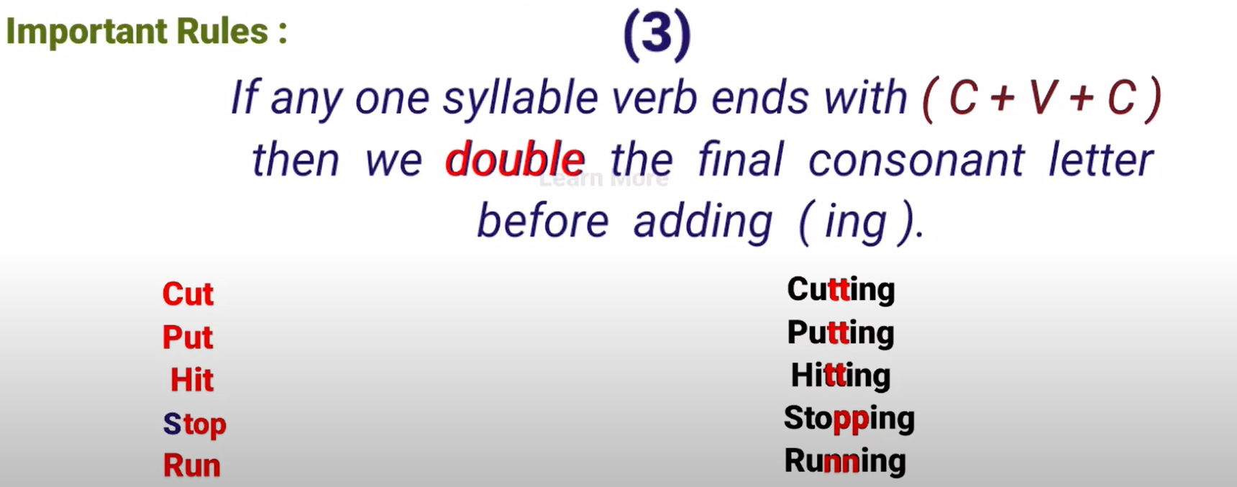

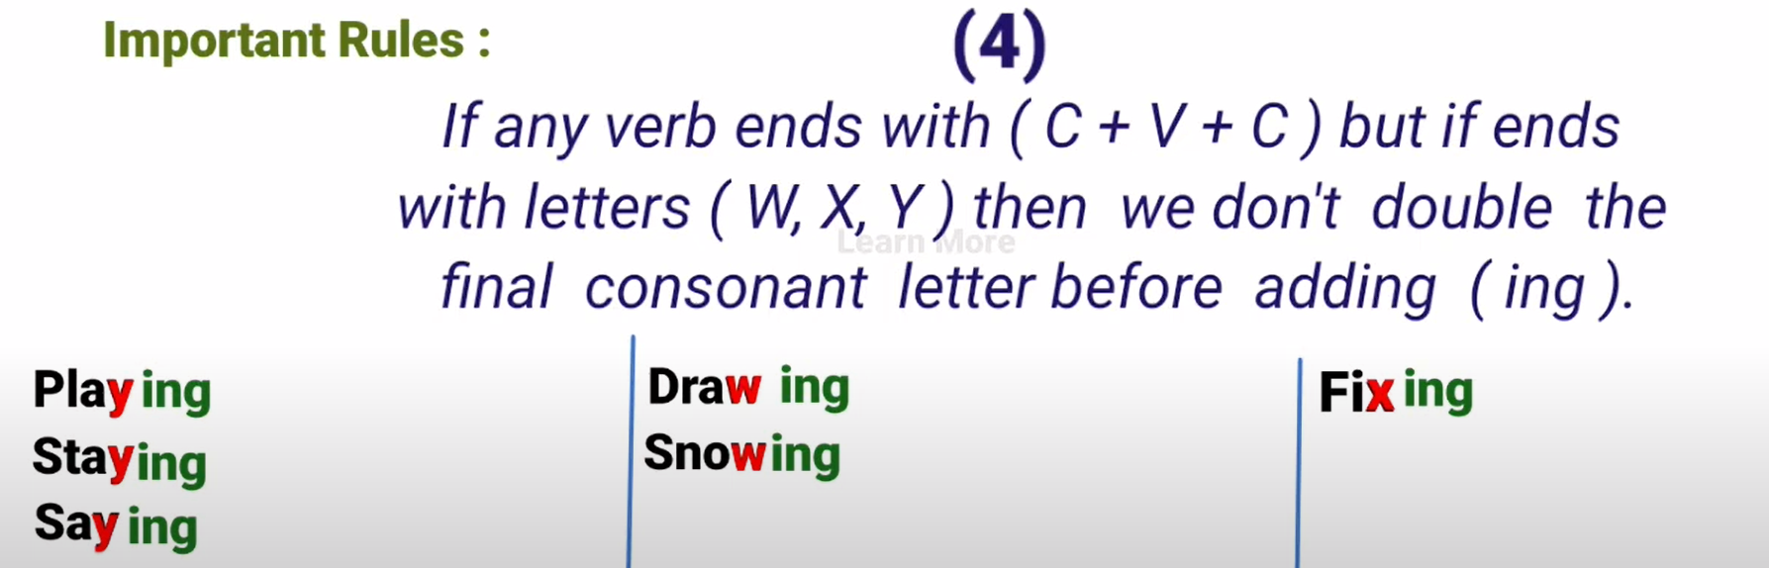

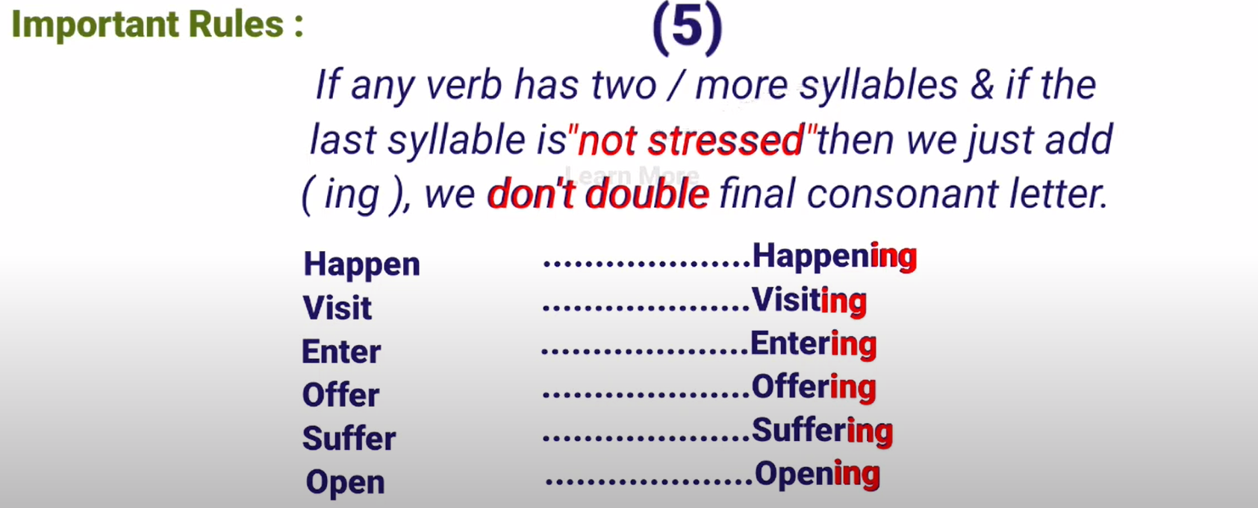

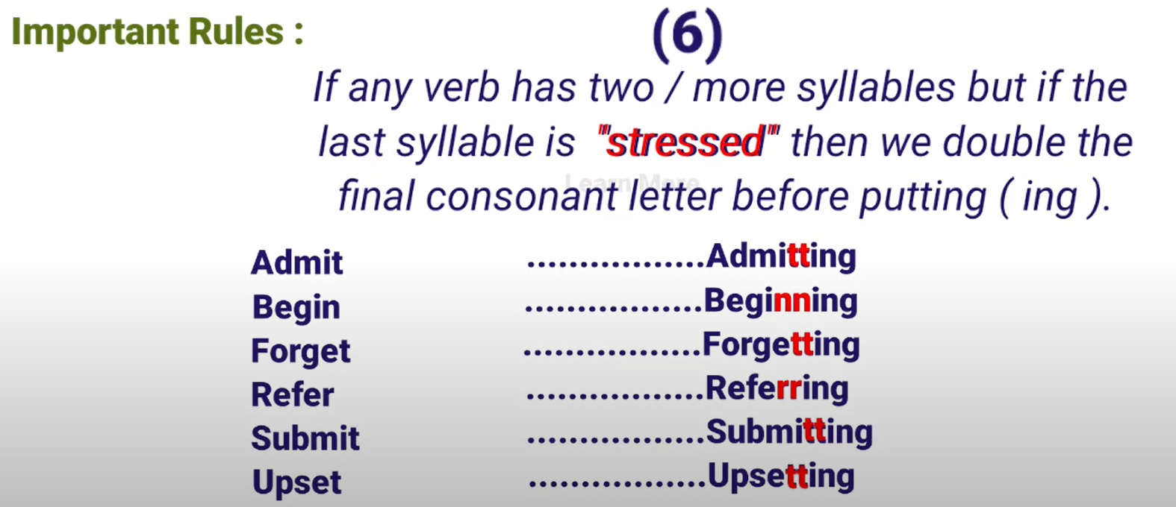

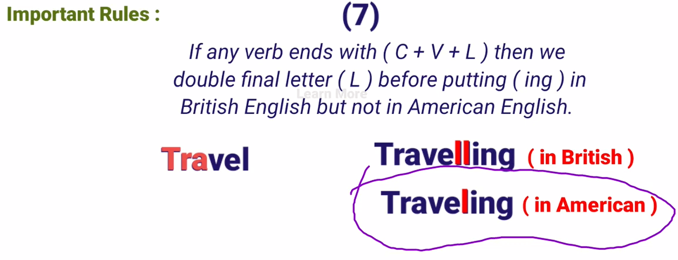

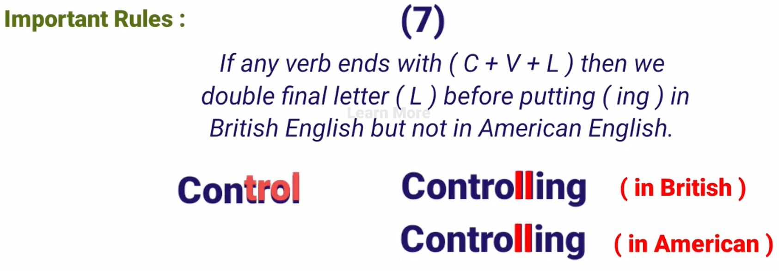

## **Kind of Sentences:**

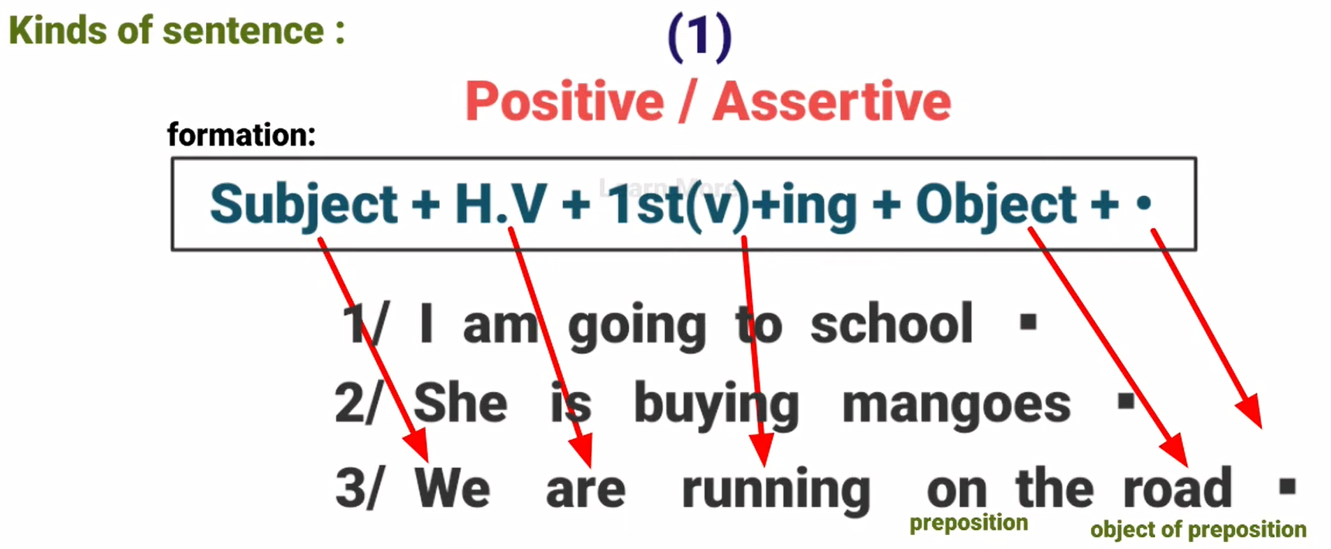

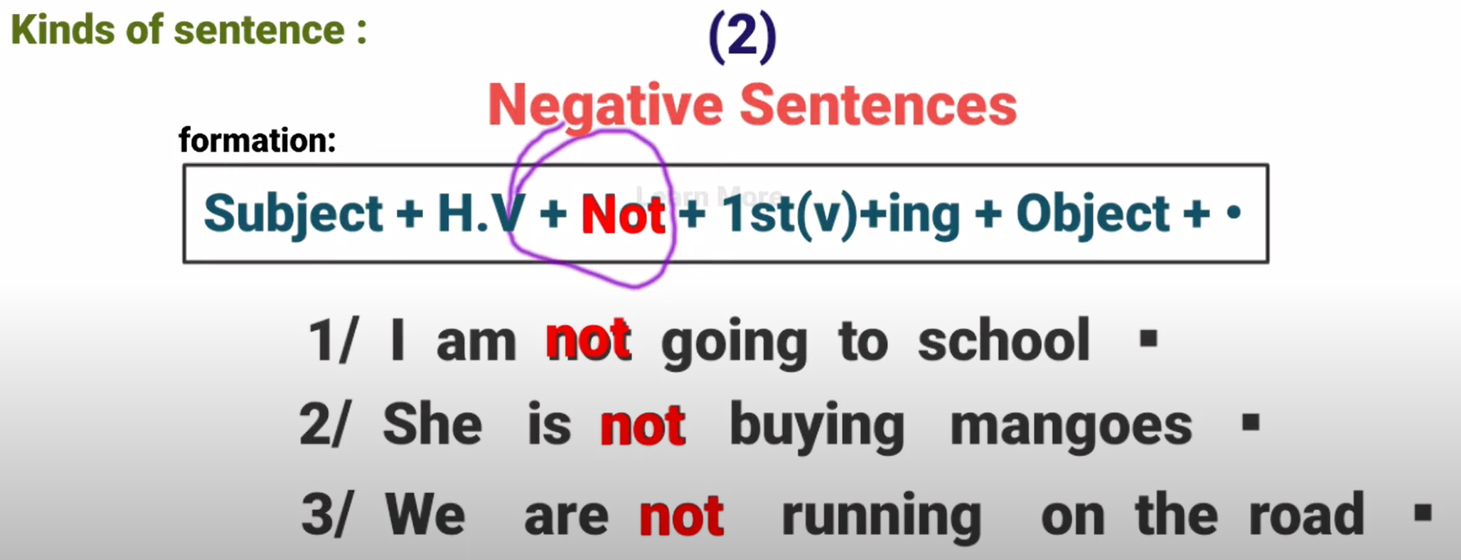

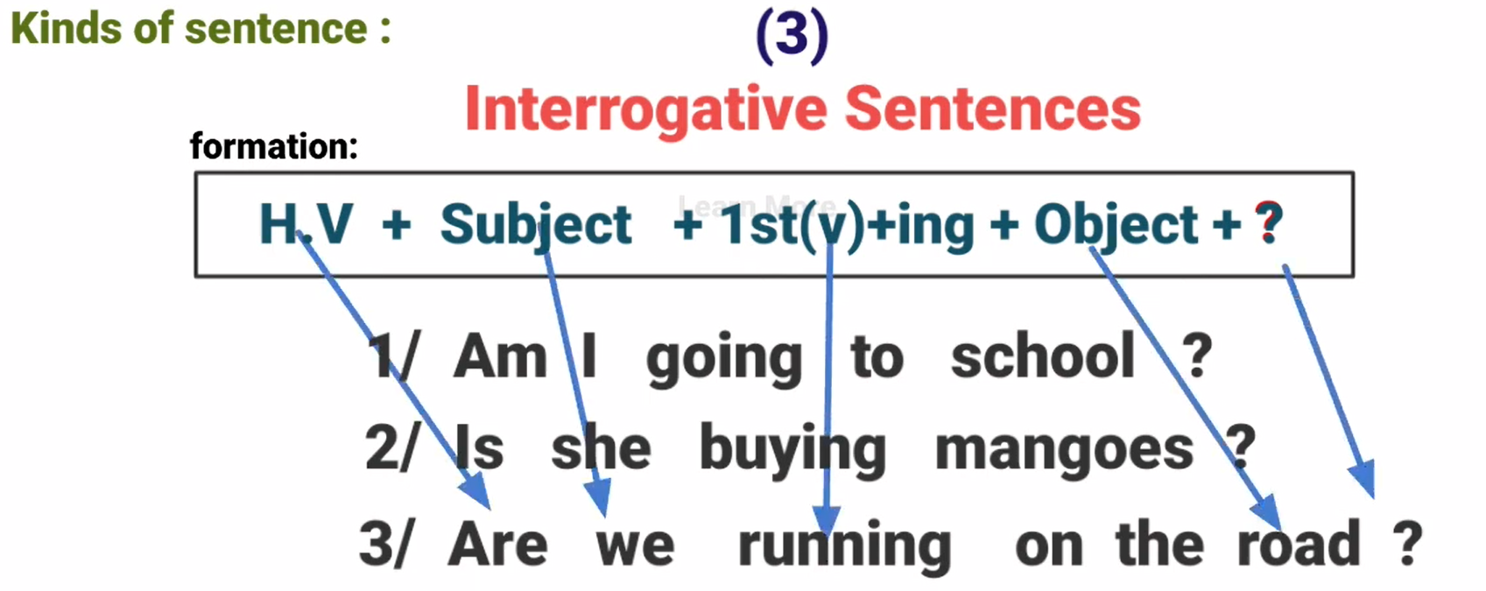

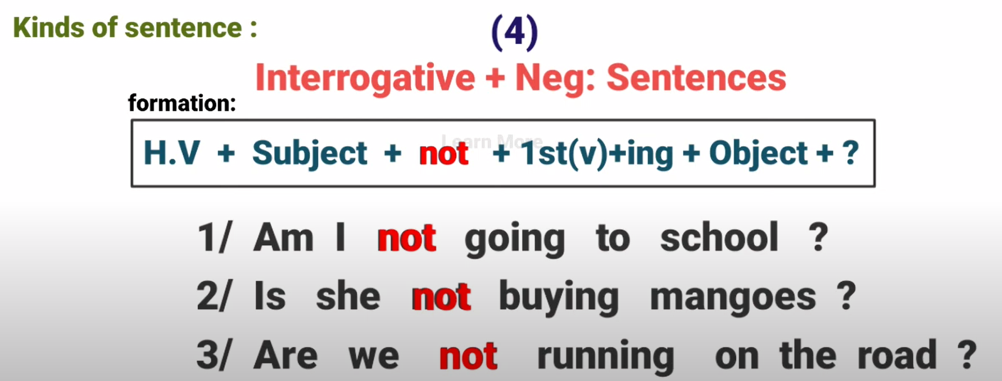

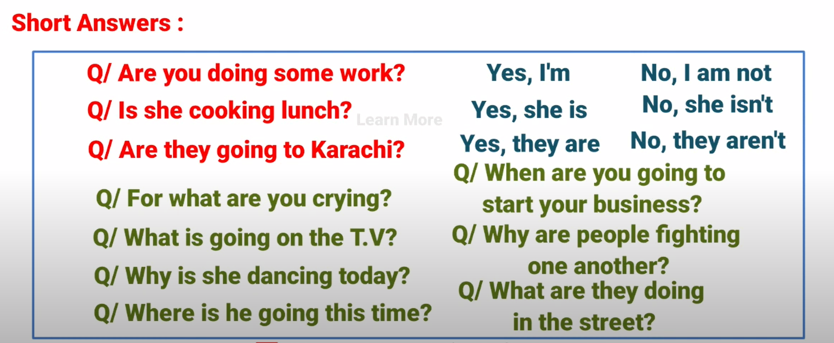

# **Present Perfect Tense:**

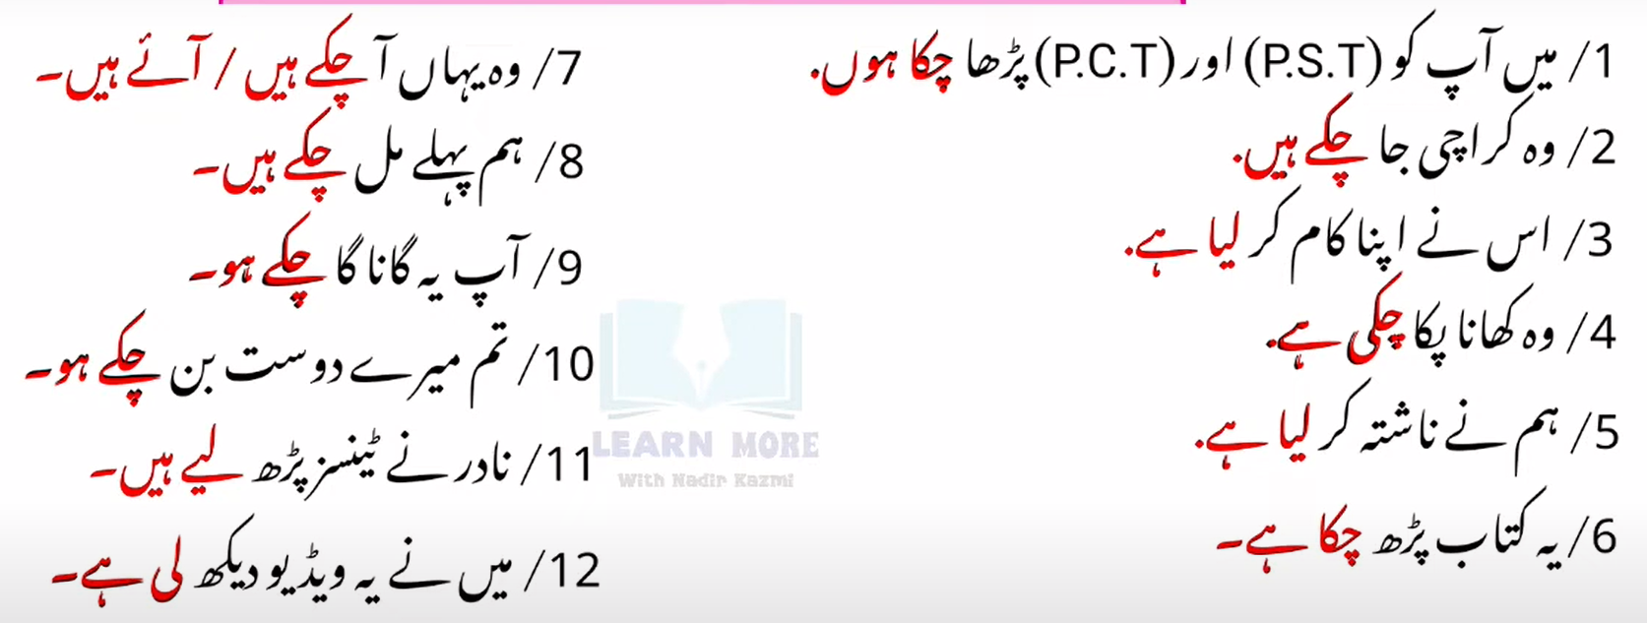

## **Definition:**

Present perfect tense tells that the subject has started some work in past and it has completed it recently in present time.

## **Helping Verbs:**

1. Has (He, she, it, and any singular subject like Nadir)
2. Have (I, We, You, they and any plural subject like Ali and Musa)

## **Form of Verb:**

3rd Form of Verb (Past participle)

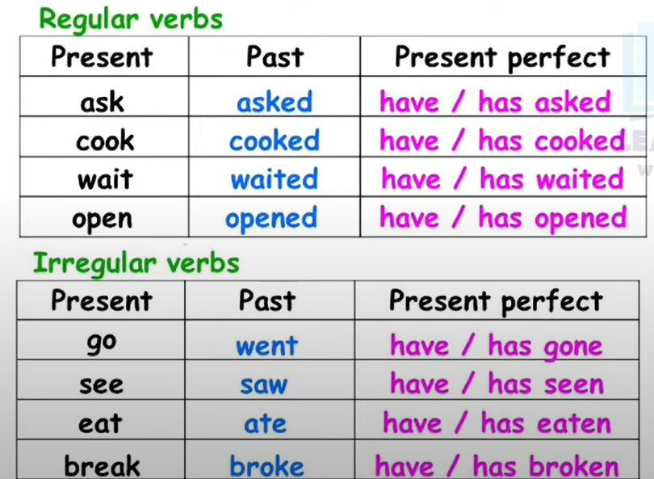

## **Examples:**

|  |  |  |
| --- | --- | --- |
| He | Has | Work**ed** |
| She | Has | Eaten |
| It | Has | Walk**ed** |
| Sofia | Has | run |

|  |  |  |
| --- | --- | --- |
| I | Have | Work**ed** |
| We | Have | Eaten |
| You | Have | Walk**ed** |
| They | Have | Slept |
| Nadir and Ali | Have | run |

## **Sentence Structure:**

### **Positive Sentence:**

* Subject + have/has + verb (v3) + object
* He has completed the mission, Aslam has completed his work.

### **Negative Sentence:**

* Subject + have/has + not + verb (v3) + object
* He has not completed the mission. Musa has not completed his assignment.

**Note:** Has not => hasn’t Have not = > Haven’t

### **Interrogative Sentence:**

* have/has + subject + verb (v3) + object + ?
* Has he completed the mission?

### **Interrogative Negative Sentence:**

* have/has + subject + not + verb (v3) + object + ?
* Has he not completed the mission?

**Wh**-**questions** begin with what, when, where, who, whom, which, whose, why and how.

Place WH-Questions before simple interrogative sentence.

* What has he done?
* Where have they gone?
* Who has told you?
* Whom have you invited?
* Which thing they have selected?

# **Present perfect Continuous Tense:**

This tense shows that the subject has started some work in the past and is still continue in present time.

## **For Instance:**

* I have been calling you for last two hours.
* He has been living here since 2000.

## **Helping Verb:**

|  |  |
| --- | --- |
| Has been | Have been |
| He | I |
| She | We |
| It | You |
| Singular Subject | They |
|  | Plural Subject |

## **Form of Verb:**

Present Participle

1st + (ing)

Go + ing

## **Examples:**

* He has been playing for two hours
* He has been laying since 2 O’clock.

## **Use of since and for:**

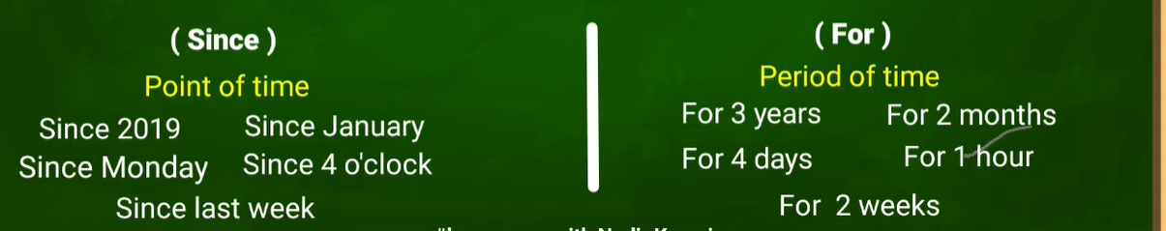

Note: For words that cannot be made plural, we will use "since" in the sentence. For words that can be made plural, we will use "for."

## **Sentence structure:**

### **Positive Sentence:**

subj + h.v (has/have) + ( p.participle ) + obj + since/ for + point/period of time + .

* You have been studying book for 2 hours.
* You have been studying book since 5 O'clock.
* She has been teaching since Monday.
* She has been teaching for 2 days.
* Waqar has been thinking since January.
* Waqar has been thinking for 3 months.
* They have been learning Grammar since 2019.
* They-have-been learning grammar for 3 years.

### **Negative Sentence:**

subj + h.v (has/have) + not + been + ( p.participle ) + obj + since/ for + point/period of time + .

* You have not been studying book for 2 hours.
* You have not been studying book since 5 O'clock.
* She has not been teaching since Monday.
* She has not been teaching for 2 days.
* Waqar has not been thinking since January.
* Waqar has not been thinking for 3 months.
* They have not been learning Grammar since 2019.
* They have not been learning grammar for 3 years.

### **Interrogative Sentence:**

h.v (has/have) + subs + been + ( p.participle ) + obj + since/ for + point/period of time + ?

* Have you been studying book for 2 hours?
* Have you been studying book since 5 O'clock?
* Has she been teaching since Monday?
* Has she been teaching for 2 days?
* Has Waqar been thinking since January?
* Has Waqar been thinking for 3 months?
* Have they been learning Grammar since 2019?
* Have they been learning grammar for 3 years?

### **Interrogative Negative Sentence:**

h.v (has/have) + subs + not + been + ( p.participle ) + obj + since/ for + point/period of time + ?

* Have you not been studying book for 2 hours?
* Have you not been studying book since 5 O'clock?
* Has she not been teaching since Monday?
* Has she not been teaching for 2 days?
* Has Waqar not been thinking since January?
* Has Waqar not been thinking for 3 months?
* Have they not been learning Grammar since 2019?
* Have they not been learning grammar for 3 years?

**\*\*\*\*\*\*\*\*\*\*\*\*\*\*\*\*\*\*\*\*\*\*\*\*\*\*\*\*\*\*\*\*\*\*\*\*\*\*\*\*\*\*\*\*\*\*\*\*\*\*\*\*\*\*\*\*\*\*\*\*\*\*\*\*\*\*\*\*\*\*\*\*\*\*\*\*\*\*\*\*\*\*\*\*\*\*\*\*\*\*\*\*\*\*\*\*\*\*\*\*\*\*\*\*\*\*\*\*\***

# **Past Tense**

# **Past Indefinite Tense:**

## **Definition:**

This tense shows that the subject performed or did any action in the past.

## **Example:**

* **Urdu**: میں نے لکھا، پڑھا، کھایا، ہم نے فلم دیکھی، اس نے کام کیا
* **English**: I wrote, I read, I ate, we watched a movie, he worked

## **Helping Verbs:**

* Did (I, We, You, They, he, she, it, Nadir)

Only use to make negative or interrogative sentences in the past. We don’t use it in positive sentences.

We also make “Emphatic” sentences by placing “Did” right after the subject in positive sentences.

For Example:

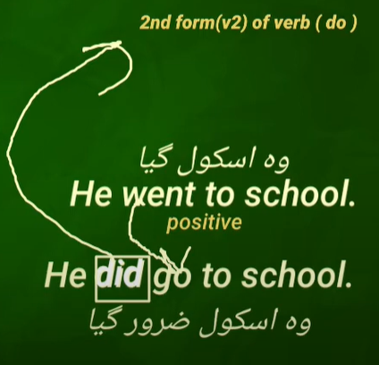

## **Form of verb:**

* 2nd form (V2) past form of verb is used

## **Sentence structure:**

### **Positive Sentence:**

Subject + V2 (past) +Object + .

* I wrote an application.
* She cooked biryani.
* They looked for you.
* You sang a song.
* We started new channel.
* He felt happy.
* Jamal attended the class.

### **Negative Sentence:**

Subject + did + not + V1 (first form) +Object + .

* I did not write an application.
* She did not cook biryani.
* They did not look for you.
* You did not sing a song.
* We did not start new channel.
* He did not feel happy.
* Jamal did not attend the class.

### **Interrogative Sentence:**

Did + Subject + V1 (first form) +Object + ?

* Did I write an application?
* Did she cook biryani?
* Did they look for you?
* Did you sing a song?
* Did we start new channel?
* Did he feel happy?
* Did Jamal attend the class?

### **Interrogative negative Sentence:**

Did + Subject + not + V1 (first form) +Object + ?

* Did I not write an application?
* Did she not cook biryani?
* Did they not look for you?
* Did you not sing a song?
* Did we not start new channel?
* Did he not feel happy?
* Did Jamal not attend the class?

# **Past Continuous Tense:**

## **Definition:**

This tense shows that the **subject** was doing an action in the past. An action was **happening** in the past.

## **Example:**

* **Urdu**: میں لکھ رہا تھا، پڑھ رہا تھا، کھا رہا تھا، بچے شور مچا رہے تھے، وہ کتاب لکھ رہی تھی
* **English**: I was writing, I was reading, I was eating, children were making noise, she was writing a book

## **Helping Verbs:**

* Was (I, he, she, it, Nadir)
* Were (We, You, They, Nadir and Ali)

## **Form of verb:**

* 1st form + ing is used

## **Sentence structure:**

### **Positive Sentence:**

Subject + H.V + (1st form + ing) + Object + .

* I was playing cricket.
* He was going to Lahore.
* She was kneading flour.
* Nadir was reading book.
* It was raining outside.
* They were fighting with one another.

### **Negative Sentence:**

Subject + H.V + not + (1st form + ing) + Object + .

* I was not playing cricket.
* He was not going to Lahore.
* She was not kneading flour.
* Nadir was not reading book.
* It was not raining outside.
* They were not/weren’t fighting with one another.

**Interrogative Sentence:**

H.V+ Subject + (1st form + ing) + Object + ?

* Was I playing cricket?
* Was he going to Lahore?
* Was she kneading flour?
* Was Nadir reading book?
* Was it raining outside?
* Were they fighting with one another?

**Interrogative negative Sentence:**

H.V + Subject + not + (1st form + ing) + Object + .

* Was I not playing cricket?
* Was he not going to Lahore?
* Was she not kneading flour?
* Was Nadir not reading book?
* Was it not raining outside?
* Were they not fighting with one another?

# **Past Perfect Tense:**

## **Definition:**

This tense shows that the **subject** had started some work in the past and had completed that action in the past.

## **Example:**

* **Urdu**: میں نے لکھ دیا تھا، میں نے پڑھ لیا تھا، اس نے کھانا کھا لیا تھا، ہم نے کام ختم کر لیا تھا
* **English**: I had written, I had read, he had eaten food, we had finished the work

## **Helping Verbs:**

* Had (I, he, she, it, Nadir, We, You, They, Nadir and Ali)

## **Form of verb:**

* 3rd form is used

## **Sentence structure:**

### **Positive Sentence:**

Subject + H.V + (3rd Form) + Object + .

* They had gone to Karachi.
* We had finished our homework.
* You had slept that night.
* I had cooked lunched.
* She had kneaded flour.
* He had said this several time.
* Nadir had arrived early in the morning.

### **Negative Sentence:**

Subject + H.V + not + (3rd Form) + Object + .

* They had not gone to Karachi.
* We had not finished our homework.
* You had not slept that night.
* I had not cooked lunched.
* She had not kneaded flour.
* He had not said this several time.
* Nadir had not arrived early in the morning.

**Interrogative Sentence:**

H.V+ Subject + (3rd Form) + Object + ?

* Had they gone to Karachi?
* Had we finished our homework?
* Had you slept that night?
* Had I cooked lunched?
* Had she kneaded flour?
* Had he said this several time?
* Had Nadir arrived early in the morning?

**Interrogative negative Sentence:**

H.V + Subject + not + (3rd Form) + Object + .

* Had they not gone to Karachi?
* Had we not finished our homework?
* Had you not slept that night?
* Had I not cooked lunched?
* Had she not kneaded flour?
* Had he not said this several time?
* Had Nadir not arrived early in the morning?

# **Past Perfect Continuous Tense:**

## **Definition:**

This tense shows that the **subject** had started some work in the past and that work continue till another time in the past.

## **Example:**

* **Urdu**: میں دو گھنٹوں سے پڑھ رہا تھا، وہ گھنٹوں سے اپنی کتاب لکھ رہی تھی، بچے شام سے پڑھائی کر رہے تھے
* **English**: I had been reading for two hours, she had been writing her book for hours, children had been studying since evening

## **Helping Verbs:**

* Had been (I, he, she, it, Nadir, We, You, They, Nadir and Ali)

## **Form of verb:**

* 1st form + ing is used

## **Use of since and for:**



## **Sentence structure:**

### **Positive Sentence:**

Subject + H.V + (1st form + ing) + Object + since/for + period/point of time + .

* I had been calling you for 3 hours.
* We had been learning grammar since morning.
* They had been quarrelling since noon.
* You had been looking us for 10 minutes.
* He had been studying since evening.
* She had been living here since January.
* Nadir had been playing for two years.

### **Negative Sentence:**

Subject + H.V (had not been) + (1st form + ing) + Object + since/for + period/point of time + .

* I had not /**hadn’t** been calling you for 3 hours.
* We had not / **hadn’t** been learning grammar since morning.
* They had not /**hadn’t** been quarrelling since noon.
* You had not been looking us for 10 minutes.
* He had not been studying since evening.
* She had not been living here since January.
* Nadir had not been playing for two years.

**Interrogative Sentence:**

H.V (had) + Subject + (been) + Object + since/for + period/point of time + ?

* Had I been calling you for 3 hours?
* Had we been learning grammar since morning?
* Had they been quarrelling since noon?
* Had you been looking us for 10 minutes?
* Had he been studying since evening?
* Had She been living here since January?
* Had Nadir been playing for two years?

**Interrogative negative Sentence:**

H.V (had) + Subject + not + (been) + Object + since/for + period/point of time + ?

* Had I not been calling you for 3 hours?
* Had we not been learning grammar since morning?
* Had they not been quarrelling since noon?
* Had you not been looking us for 10 minutes?
* Had he not been studying since evening?
* Had She not been living here since January?
* Had Nadir not been playing for two years?

**\*\*\*\*\*\*\*\*\*\*\*\*\*\*\*\*\*\*\*\*\*\*\*\*\*\*\*\*\*\*\*\*\*\*\*\*\*\*\*\*\*\*\*\*\*\*\*\*\*\*\*\*\*\*\*\*\*\*\*\*\*\*\*\*\*\*\*\*\*\*\*\*\*\*\*\*\*\*\*\*\*\*\*\*\*\*\*\*\*\*\*\*\*\*\*\*\*\*\*\*\*\*\*\*\*\*\*\*\***

# **Future Tense**

# **Future Indefinite Tense:**

## **Definition:**

This tense shows that the subject will perform / do an action in the coming future.

## **Example:**

* **Urdu**: میں پڑھوں گا، کھاؤں گا، ہم سکول جائیں گے، وہ اپنا کام مکمل کرے گا
* **English**: I will read, I will eat, we will go to school, he will complete his work

## **Helping Verbs:**

**For Simple Sentences:**

* Will (2nd Person (You) and He, she It, They, Nadir)
* Shell (1st Person (I & We))

**For Example:**

I shell eat food, He will eat food.

**For Emphatic Sentences:**

* Shell (2nd Person (You) and He, she It, They, Nadir)
* Will (1st Person (I & We))

**For Example:**

I will eat food, He shell eat food.

**In modern English only will is used with all the subjects**

## **Form of verb:**

* 1st form of verb is used

## **Sentence structure:**

### **Positive Sentence:**

Subject + will + M.V (main verb) + Object + .

* I will play cricket.
* You will learn English.
* You will buy a car.
* They will come a home.
* He will say them.
* She will recite holy Quran.
* It will rain tomorrow.
* Nadir will offer Nimaz.

### **Negative Sentence:**

Subject + will + not + M.V (main verb) + Object + .

* I will not play cricket. (will not / **won’t**)
* You will not learn English.
* You will not buy a car.
* They will not come a home.
* He will not say them.
* She will not recite holy Quran.
* It will not rain tomorrow.
* Nadir will not offer Nimaz.

### **Interrogative Sentence:**

Will + Subject + M.V (main verb) +Object + ?

* Will I play cricket?
* Will you learn English?
* Will you buy a car?
* Will they come a home?
* Will he say them?
* Will she recite holy Quran?
* Will it rain tomorrow?
* Will Nadir offer Nimaz?

### **Interrogative negative Sentence:**

Will + Subject + not + M.V (main verb) +Object + ?

* Will I not play cricket? | Won’t I paly cricket?
* Will you not learn English?
* Will you not buy a car?
* Will they not come a home?
* Will he not say them?
* Will she not recite holy Quran?
* Will it not rain tomorrow?
* Will Nadir not offer Nimaz?

____________________________________________________________________________

# **Future Continuous Tense:**

## **Definition:**

This tense shows that the subject will be doing some action in the future.

## **Example:**

* **Urdu**: میں پڑھ رہا ہوں گا، لکھ رہا ہوں گا، وہ کہانی سن رہا ہوگا، بچے باغ میں دوڑ رہے ہوں گے
* **English**: I will be reading, I will be writing, he will be listening to a story, children will be running in the garden

## **Helping Verbs:**

* Will be (2nd Person (You) and He, she It, They, Nadir)
* Shell be (1st Person (I & We))

**In modern English only will be is used with all the subjects**

## **Form of verb:**

* 1st form + ing is used

## **Sentence structure:**

### **Positive Sentence:**

Subject + will be + (1st form + ing) + Object + .

* I will be playing cricket tomorrow.
* We will be dancing at his party.
* You will be fighting at that time.
* They will be hugging each other.
* He will be saying that.
* She will be kneading flour.
* It will be raining tomorrow
* Nadir will be thinking about this.

### **Negative Sentence:**

Subject + will + not + be + (1st form + ing) + Object + .

* I will not be playing cricket tomorrow. (will not = won’t)
* We will not be dancing at his party.
* You will not be fighting at that time.
* They will not be hugging each other.
* He will not be saying that.
* She will not be kneading flour.
* It will not be raining tomorrow
* Nadir will not be thinking about this.

### **Interrogative Sentence:**

Will + Subject + be + (1st form + ing) + Object + ?

* Will I be playing cricket tomorrow?
* Will we be dancing at his party?
* Will you be fighting at that time?
* Will they be hugging each other?
* Will he be saying that?
* Will she be kneading flour?
* Will it be raining tomorrow?
* Will Nadir be thinking about this?

**WH Questions:**

* + What will he be doing?
  + When will he be doing?
  + Where will he be doing?

### **Interrogative negative Sentence:**

Will + Subject + not + be + (1st form + ing) + Object + ?

* Will I not be playing cricket tomorrow? | **Won’t** I be playing cricket tomorrow?
* Will we not be dancing at his party?
* Will you not be fighting at that time?
* Will they not be hugging each other?
* Will he not be saying that?
* Will she not be kneading flour?
* Will it not be raining tomorrow?
* Will Nadir not be thinking about this?

____________________________________________________________________________

# **Future Perfect Tense:**

## **Definition:**

This tense shows that the subject “will have done/completed” some action in the future.

## **Example:**

* **Urdu**: میں نے لکھ دیا ہوگا، میں نے پڑھ لیا ہوگا، ہم نے کھانا کھا لیا ہوگا، بچوں نے ہوم ورک ختم کر لیا ہوگا
* **English**: I will have written, I will have read, we will have eaten, children will have completed their homework.

## **Helping Verbs:**

* Will have (2nd Person (You) and He, she It, They, Nadir)
* Shell have (1st Person (I & We))

**In modern English only will have is used with all the subjects**

## **Form of verb:**

* 3rd form is used

## **Sentence structure:**

### **Positive Sentence:**

Subject + will have + V3 + Object + .

* I will have completed my degree.
* I will have completed my pending work.
* We will have gone at this time tomorrow.
* You will have achieved your reward.
* They will have come earlier than us tomorrow.
* He will have made him agreed.
* She will have taken care of all arrangements.
* It will have rained before the match started tomorrow.
* Nadir will have done his job.

### **Negative Sentence:**

Subject + will + not + have + V3 + Object + .

* I will not have completed my degree. | I won’t have completed my degree
* I will not have completed my pending work.
* We will not have gone at this time tomorrow.
* You will not have achieved your reward.
* They will not have come earlier than us tomorrow.
* He will not have made him agreed.
* She will not have taken care of all arrangements.
* It will not have rained before the match started tomorrow.
* Nadir will not have done his job.

### **Interrogative Sentence:**

Will + Subject + have + V3 + Object + .

* Will I have completed my degree?
* Will I have completed my pending work?
* Will we have gone at this time tomorrow?
* Will you have achieved your reward?
* Will they have come earlier than us tomorrow?
* Will he have made him agreed?
* Will she have taken care of all arrangements?
* Will it have rained before the match started tomorrow?
* Will Nadir have done his job?

### **Interrogative negative Sentence:**

Will + Subject + not + have + V3 + Object + .

* Will I not have completed my degree? | **Won’t I** **have** completed my degree?
* Will I not have completed my pending work?
* Will we not have gone at this time tomorrow?
* Will you not have achieved your reward?
* Will they not have come earlier than us tomorrow?
* Will he not have made him agreed?
* Will she not have taken care of all arrangements?
* Will it not have rained before the match started tomorrow?
* Will Nadir not have done his job?

**WH Questions:**

* + When will I have completed my degree?
  + Where will I have completed my degree?

____________________________________________________________________________

# **Future Perfect Continuous Tense:**

## **Definition:**

This tense shows an action that will have started in future and that work will still be in progress in the future till another time.

## **Example:**

* **Urdu**: میں دو گھنٹوں سے پڑھ رہا ہوں گا، وہ کئی دنوں سے لکھ رہا ہوگا، بچے دوپہر سے کھیل رہے ہوں گے
* **English**: I will have been reading for two hours, he will have been writing for many days, children will have been playing since afternoon.

## **Helping Verbs:**

* Will have been (2nd Person (You) and He, she It, They, Nadir)
* Shell have been (1st Person (I & We))

**In modern English only will have been is used with all the subjects**

## **Form of verb:**

* 1st form + ing is used

## **Sentence structure:**

### **Positive Sentence:**

Subject + will + have + been + (1st form + ing) + Object + Since/for + period/point of time + .

* At 4 o’clock we will have been waiting you for one hour.
* She will have been sleeping at home for two hours when we arrive.
* He will have been playing the guitar for ten years when he turns twenty.
* They will have been teaching German for 5 years by the end of this years.
* I will have been travelling to Japan by this time next week.
* When I am at school, my family will have been flying to New York.

### **Negative Sentence:**

Subject + will + not + have + been + (1st form + ing) + Object + Since/for + period/point of time + .

* They will not have been going for a picnic.
* We will not have been living there for two years by the end of this year.
* I will not have been studying in London next summer.
* She will not have been studying Japan next year.
* The president will not have been talking tomorrow.
* I will not have been searching for a new issue on internet tomorrow afternoon.

### **Interrogative Sentence:**

Will + Subject + have + been + (1st form + ing) + Object + Since/for + period/point of time + .

* Will the baby have been playing with toys for one hour?
* Will you have been speaking English for two years by the end of this year?
* Will you have been making a cake in the kitchen?
* Will they have been playing tennis since morning?
* Will you have been working for a long time?
* Will she have been teaching French for 10 years next year?

### **Interrogative negative Sentence:**

Will + Subject + not + have + been + (1st form + ing) + Object + Since/for + period/point of time + .

* **Won’t |** Will the baby not have been playing with toys for one hour?
* Will you not have been speaking English for two years by the end of this year?
* Will you not have been making a cake in the kitchen?
* Will they not have been playing tennis since morning?
* Will you not have been working for a long time?
* Will she not have been teaching French for 10 years next year?